**Shooting Stars Preschool – Terms & Conditions**

The academic year at Shooting Stars is divided into 2 semesters. We follow the Unterägeri school holidays.

**Fees:**

Morning preschool session: CHF 58 per session

Morning preschool and phonics: CHF 60 per session

**Sibling discount:**

Siblings attending any Shooting Stars classes are entitled to a 10% discount

**Fee Calculation:**

Fees are calculated based on the number of sessions per term, less any holidays observed by the Unteraegeri Gemeinde.

**Fee Review:**

Fees are reviewed every August.

**Payment of fees:**

Fees are payable per semester in advance by the payment date on the invoice.

**Waiting List Policy and Procedure:**

A child is placed on the waiting list in the order of the date on which the registration form is received. Places are subject to availability.

**Changing days and or giving notice:**

We plan our staffing according to numbers of children. Therefore, if you wish to withdraw your child from preschool there will be no refund of fees. A written notice is required 8 weeks before the start of the new semester if you wish to withdraw your child or reduce the number of mornings your child attends pre-school. If notice of cancellation is received after this time then the 2nd semester fee will need to be paid.

Increases in attendance and day changes are subject to availability.

**Ad hoc Additional days:**

Ad hoc additional days can sometimes be accommodated, please contact us in advance to see if there is any availability.

**Absences:**

Fees are non-refundable in cases of child sickness or family holidays. We do not offer reductions or alternative days for any absences. In the unlikely event a session has to be cancelled due to teacher sickness, a refund will be offered. Cases of force majeure are excluded.

**Illness:**

If your child becomes ill, or has an accident while attending Shooting Stars, we will contact you by telephone. If there is no reply we will contact your emergency contact numbers. Please ensure these are always up-to-date and inform us if emergency contacts/mobile numbers change during the year.

If your child has had a fever, been vomiting or had diarrhoea, please be aware that they must be clear of these symptoms (without medication) for at least 48 hours before coming back to pre-school.

**Trial Session:**

You are welcome to attend a free trial session with your child.

**Settling in:**

All children are different and respond in different ways; some are ready to be left almost immediately, whilst for others it is a longer process. We will work with you to ensure that the settling in process is appropriate for your child.

**Insurance:**

Shooting Stars is covered by an accident insurance policy, however it is the responsibility of the parents to provide personal insurance as they feel necessary.

**Snacks:**

An important part of our day is snack time. The children sit together, learn to socialise and enjoy each other’s company. With this in mind we ask all parents to send their child with a healthy snack and water bottle.

**Appropriate Clothing:**

Please ensure that your child comes to Shooting Stars in suitable clothing. We encourage the children to experiment with their surroundings but cannot accept responsibility for stains or damage to clothes caused whilst at preschool. They will get messy so old clothes are best. Please provide a spare set of clothes for your child to keep in the playroom. Please also provide your child with outdoor clothes appropriate for the weather. We aim to go outside as much as possible. Parents are to provide nappies when necessary.

**Shooting Stars Preschool – Registration Form**

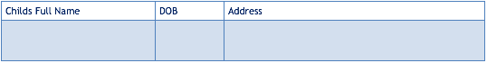



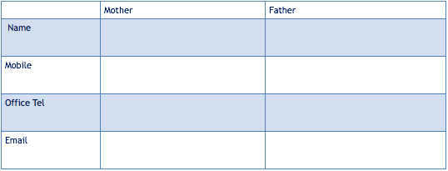

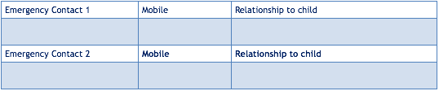

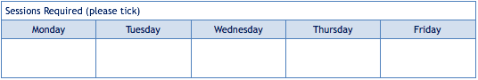

Any other comments/ allergies etc ………………………………………………………………………………………………………………………………………………………………………………………………………………………………………………………………………………………………………………………………………………………………………………………………………………………………………………………………………………………………………………………………………………………………………………………………………………………………………………………………………………………………………………………………………………………………………………………………………………………………………………………………………………………………………………………………………………………………………………………

I give my permission for photos of my child to be used on:

Shooting Stars facebook & Instagram page yes/no

Shooting Stars website yes/no

Shared with other Shooting Stars parents yes/no

By signing this registration form I agree to the Terms and Conditions of Shooting Stars Preschool and wish to reserve a place for my child(ren).

Signed ……………………………………………………………………..

Date………………………………………………